**INDIAN INSTITUTE OF TECHNOLOGY, DELHI**



**SESSION:2021-22**

**PROJECT REPORT**

**COURSE: IEC LABORATORY**

**TASK: DESIGN A MOD-5 SYNCHRONOUS COUNTER USING JK FLIP FLOP**

***SUBMITTED BY: RIYA CHORDIA***

***ENTRY NO: 2021EEN2024***

***MTECH PROGRAMME: INTEGRATED ELECTRONICS AND CIRCUITS***

***TARGETS ACHIEVED:***

* ***MOD-5 Synchronous counter is made using master-slave JK flip flop.***
* ***The counter counts from 0 to 4.***
* ***All layouts are made from scratch with a minimum height of 1.4 micrometre.***
* ***Width of MOD 5 counter layout is 80.5 micrometres***
* ***Area= (1.4*80.5) micrometres***

**=112.7 micrometres**

* **Timing information including rise time, fall time, propogation delay from low to high and high to low have been calculated for all the circuits and mentioned in the report.**
* **DRC, LVS and PEX analysis of all the circuits has been successfully done.**
* **Width of NMOS is kept 200nm and width of PMOS is kept 400nm.**
* **Clock frequency = 250MHz**
* **Schematics, simulations, layouts and post layout simulation of all the circuit blocks has been successfully done and are shown in this report.**
* **Performed simulation of counter layout at 2GHz, 2.5GHz, 3GHz. The simulation works fine for these frequencies.**
* **At 3.3GHz the counter shows incorrect results. Plots are shown in the report.**
* **So the maximum frequency at which counter works is between 3GHz to 3.3GHz.**
* **Setup time for the counter calculated is: 66.88ps**

***TARGET REMAINING:***

* ***Hold time of the counter***

**INVERTER**

**Schematic Diagram:**

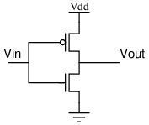

**Simulation:**

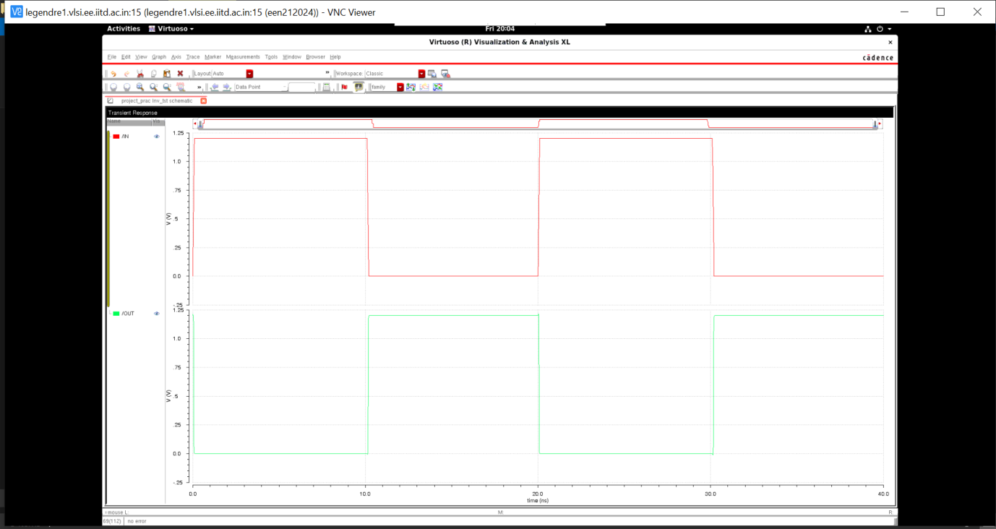

**Layout:**

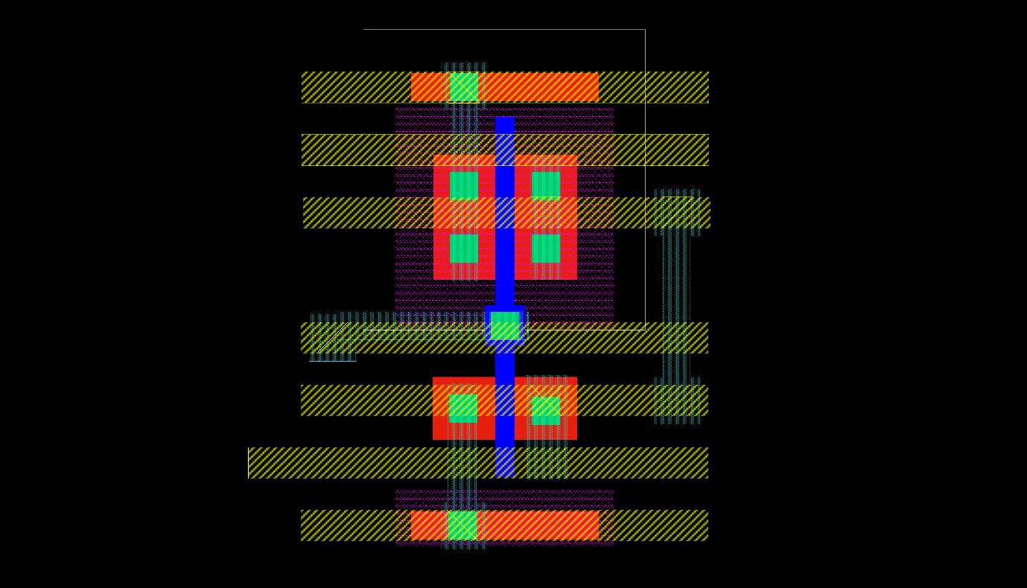

**Post Layout Simulation:**

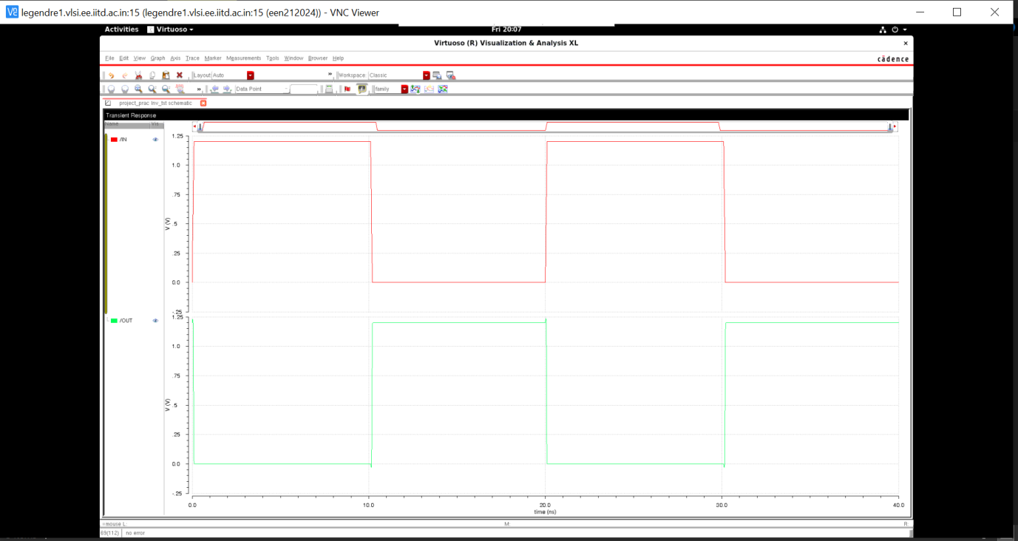

**TIMING INFORMATION:**

**RISE TIME: 13.47 E -21 s FALL TIME: 22.44p s**

**DELAY TIME: tpLH {low to high} and tpHL {high to low}**

**TpLH: 16.78p s tpHL: 16.78p s**

**2 INPUT NAND GATE**

**Schematic Diagram:**

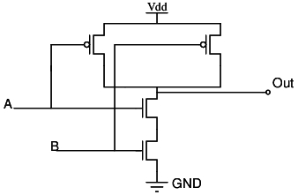

**Simulation:**

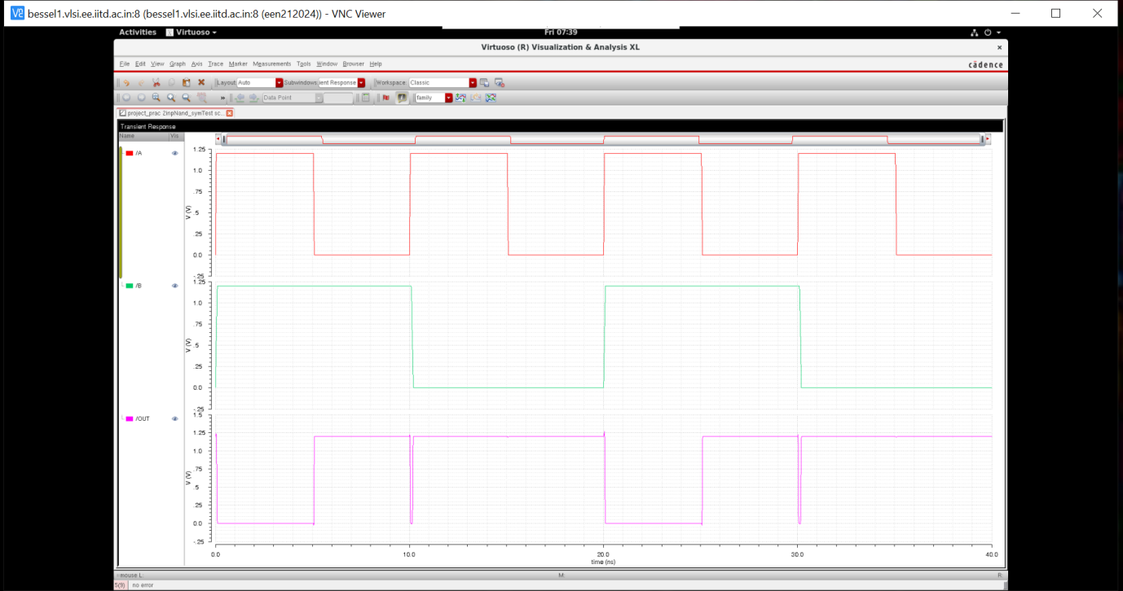

**Layout:**

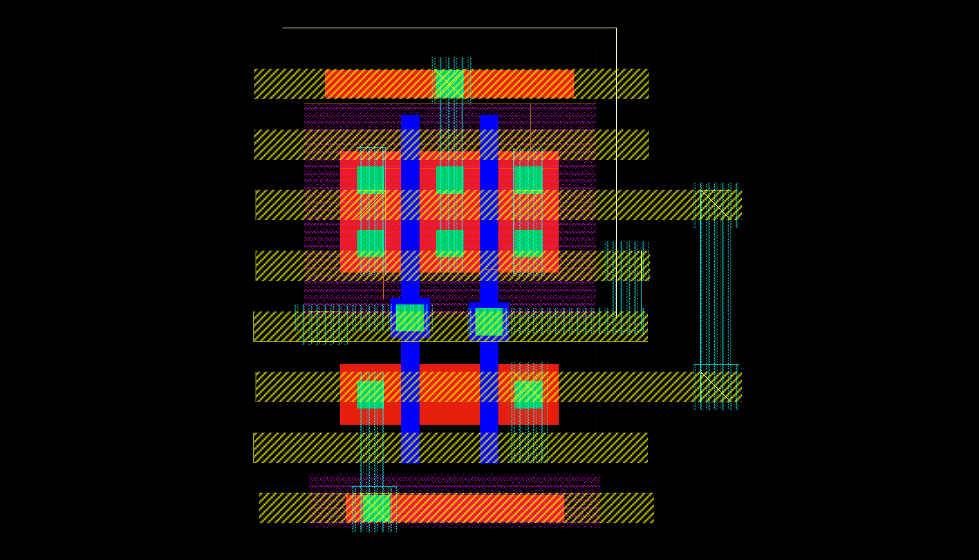

**Post Layout Simulation:**

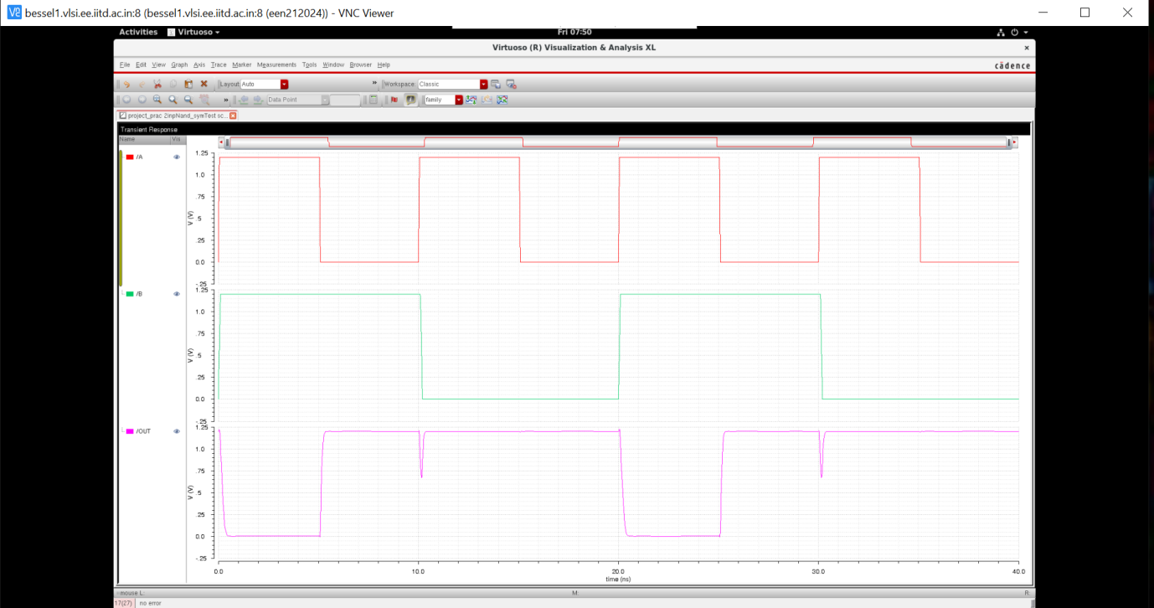

**TIMING INFORMATION:**

**RISE TIME: 196.8E-18 s FALL TIME: 23.83p s**

**DELAY TIME: tpLH {low to high} and TpHL {high to low}**

**TpLH: 5.096n s tpHL: 9.951n s**

**3 INPUT NAND GATE**

**Schematic Diagram:**

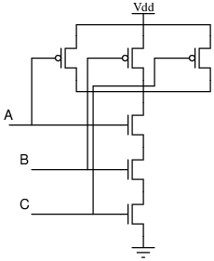

**Simulation:**

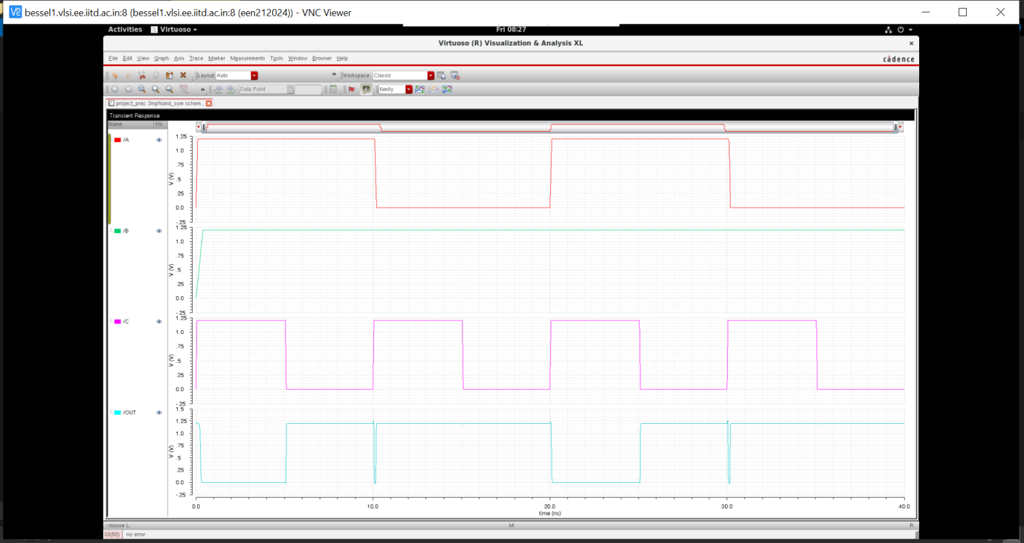

**Layout:**

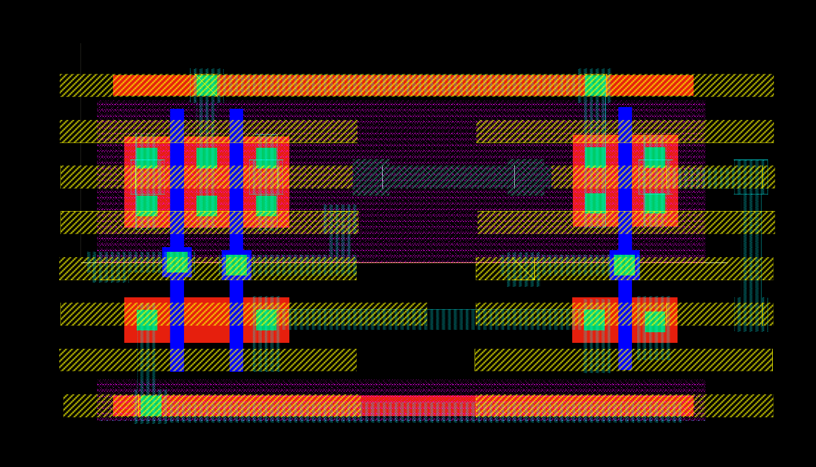

**Post Layout Simulation:**

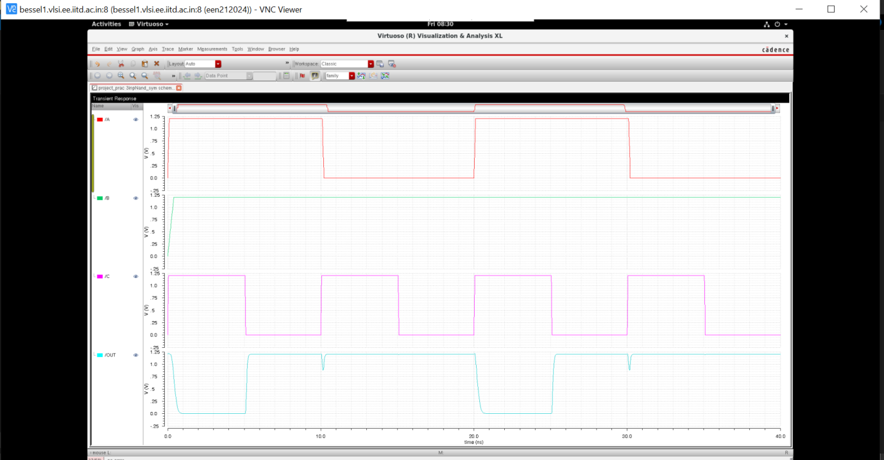

**TIMING INFORMATION:**

**RISE TIME: 354.3p s FALL TIME: 354.3p s**

**DELAY TIME: tpLH {low to high} and TpHL {high to low}**

**TpLH: 20.08E-9 s tpHL: 9.583E-9 s**

**AND GATE**

**Schematic Diagram:**

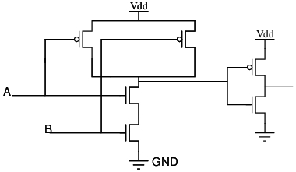

**Simulation:**

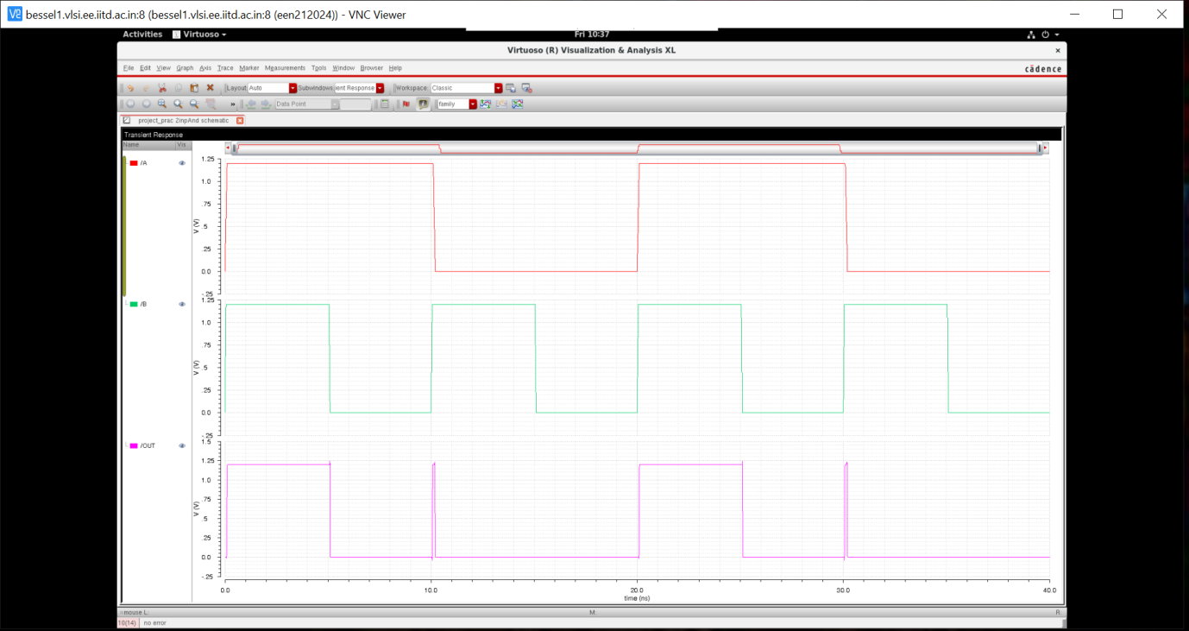

**Layout:**

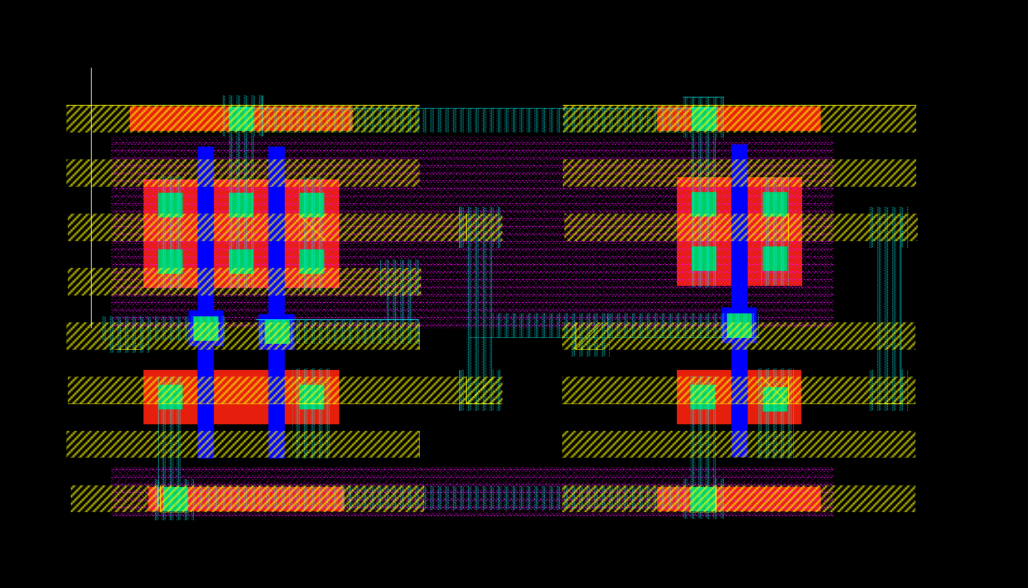

**Post Layout Simulation:**

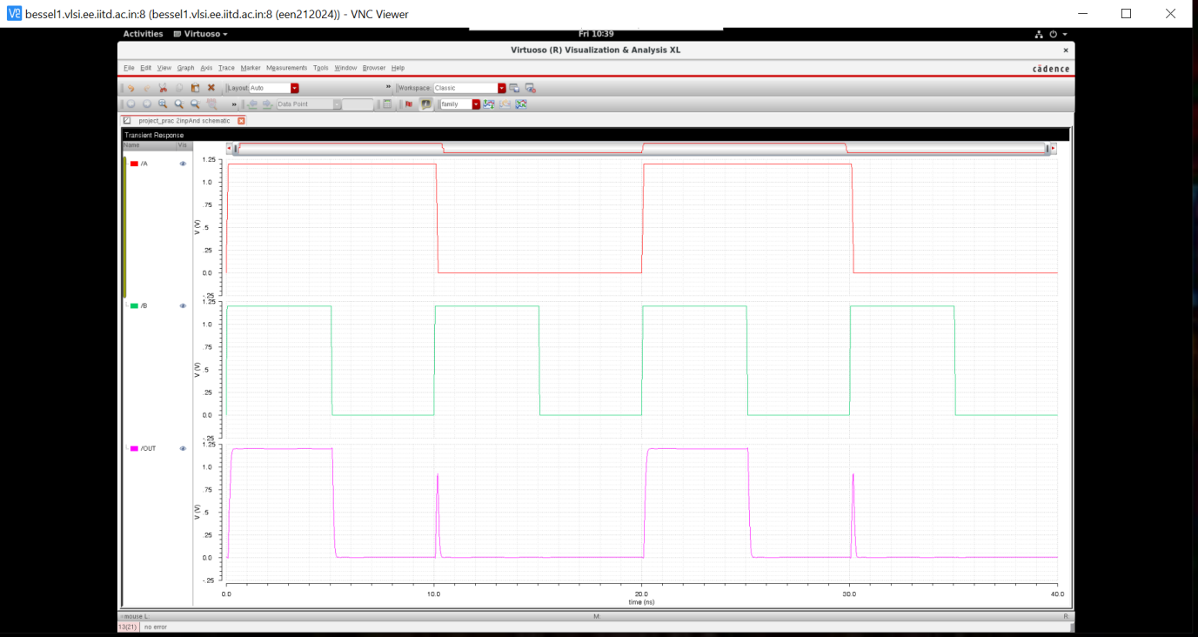

**TIMING INFORMATION:**

**RISE TIME: 2.049E -18 s FALL TIME: 123.3p s**

**DELAY TIME: tpLH {low to high} and TpHL {high to low}**

**TpLH: 5.049n s tpHL: 4.859n s**

**SR LATCH**

**Schematic Diagram:**

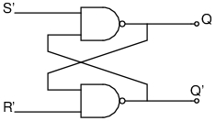

**Simulation:**

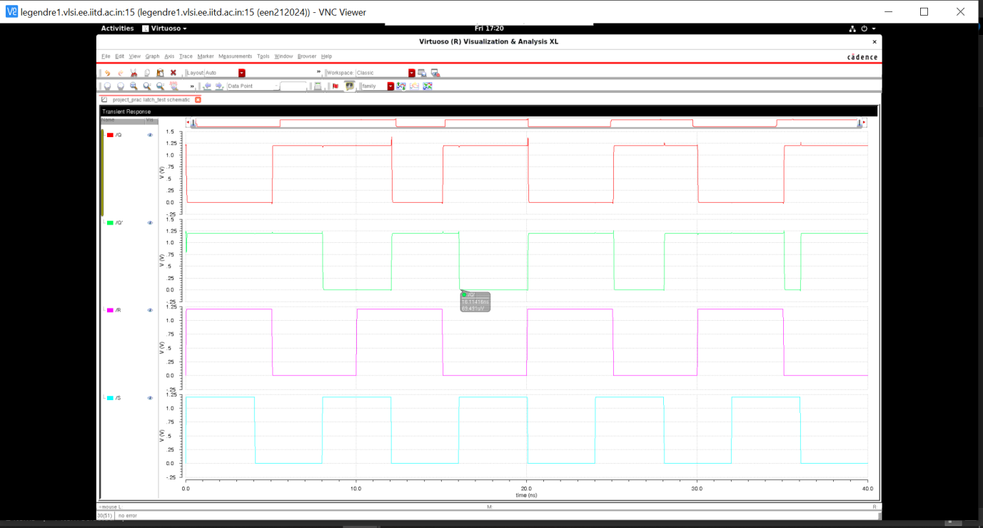

**Layout:**

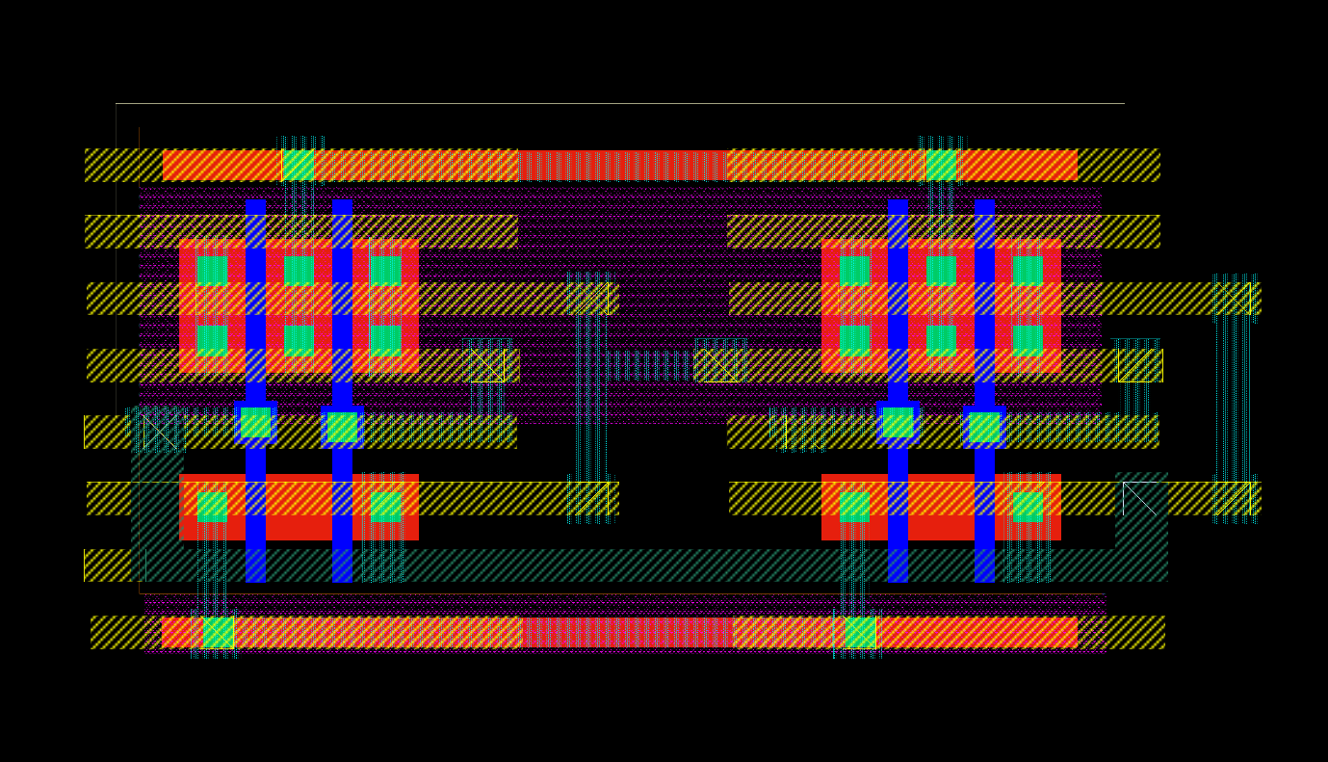

**Post Layout Simulation:**

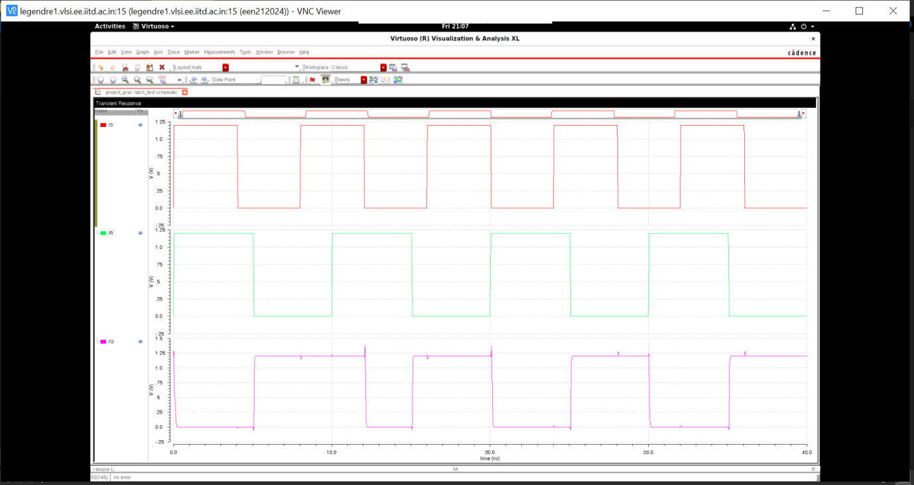

**TIMING:**

**RISE TIME: 218.3E -18 s FALL TIME: 124.3p s**

**DELAY TIME: tpLH {low to high} and TpHL {high to low}**

**TpLH: 6.78n s tpHL: 6.98n s**

**JK FLIP FLOP**

**Schematic Diagram:**

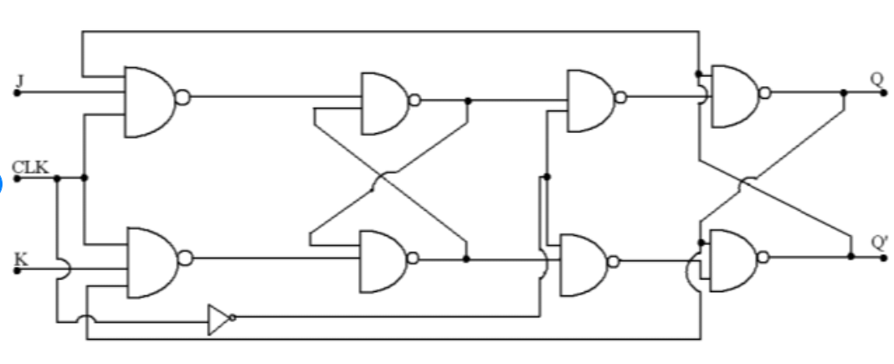

**Simulation:**

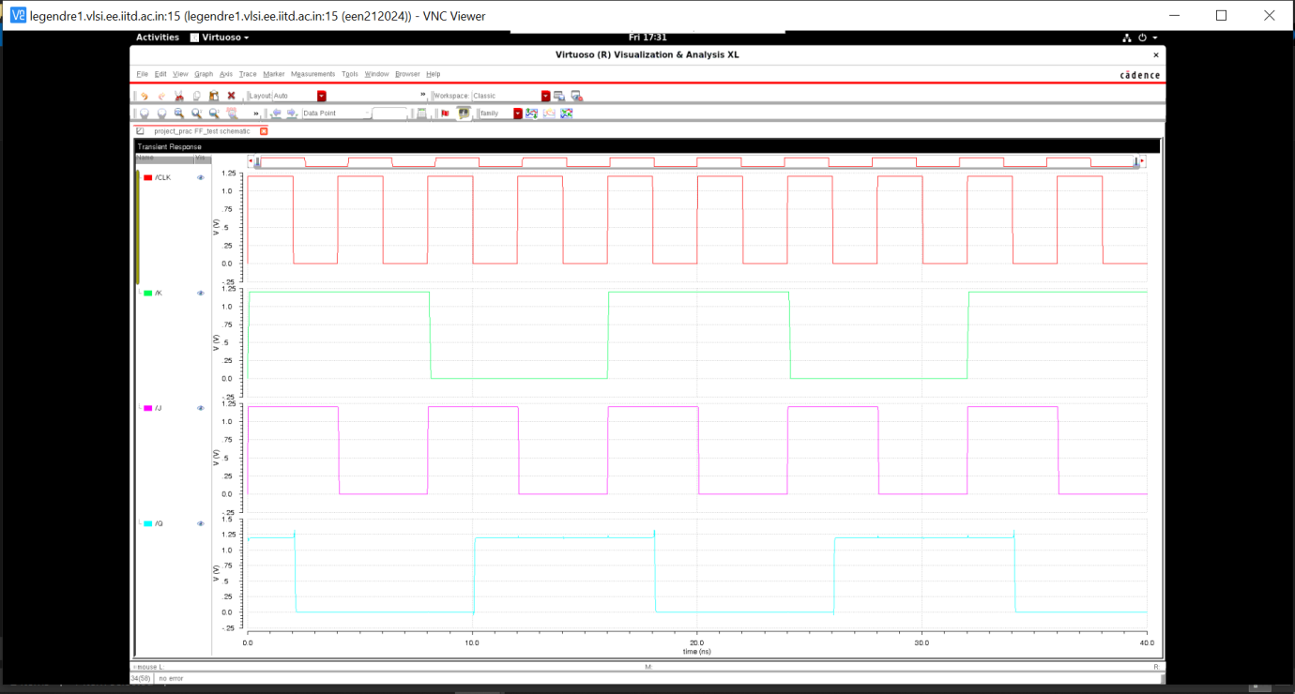

**Layout:**

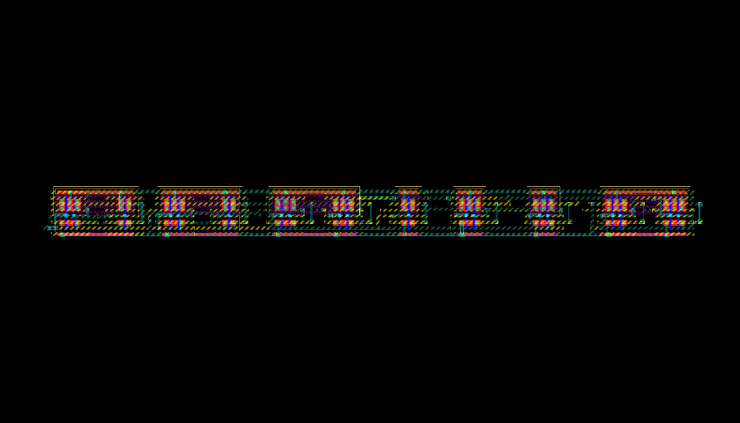

**Post Layout Simulation:**

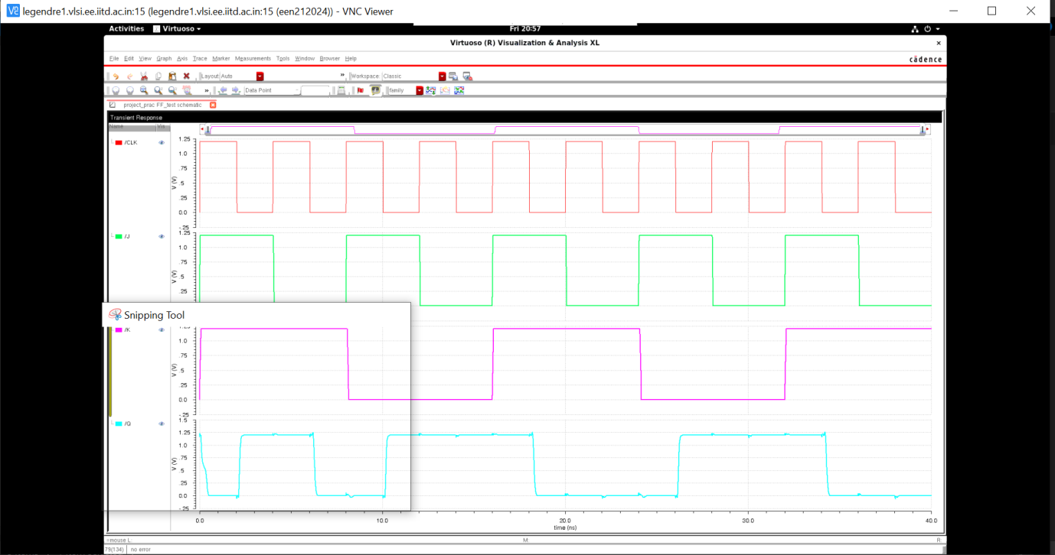

**TIMING INFORMATION:**

**RISE TIME: 330.2p s FALL TIME: 342.5p s**

**DELAY TIME: tpLH {low to high} and TpHL {high to low}**

**TpLH: 6.136n s tpHL: 7.087n s**

**COUNTER**

**Schematic Diagram:**

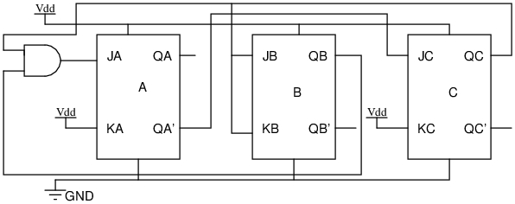

**Simulation(At 250MHz):**

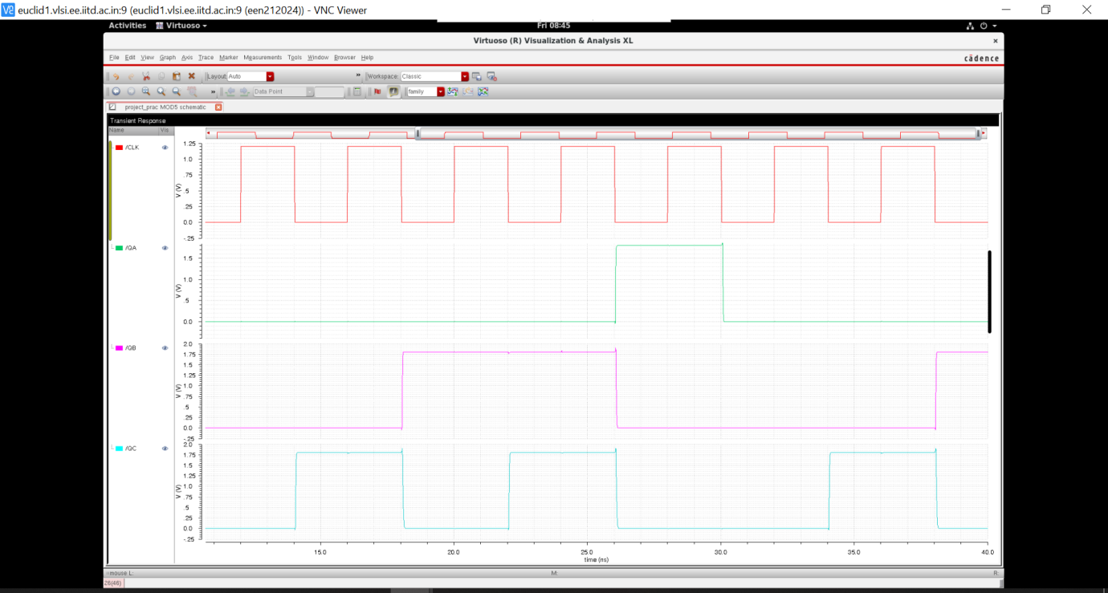

**Layout:**



**Post Layout Simulation:**

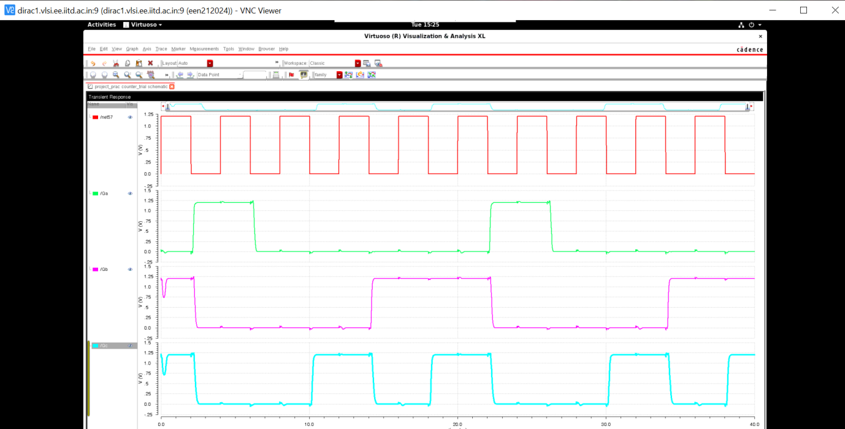

**TIMING INFORMATION(QA):**

**RISE TIME: 123.2p s FALL TIME: 121.5p s**

**DELAY TIME: tpLH {low to high} and TpHL {high to low}**

**TpLH: 6.285n s tpHL: 7.112n s**

**Simulation performed at different clock frequencies:**

**Simulation(At 2GHZ):**

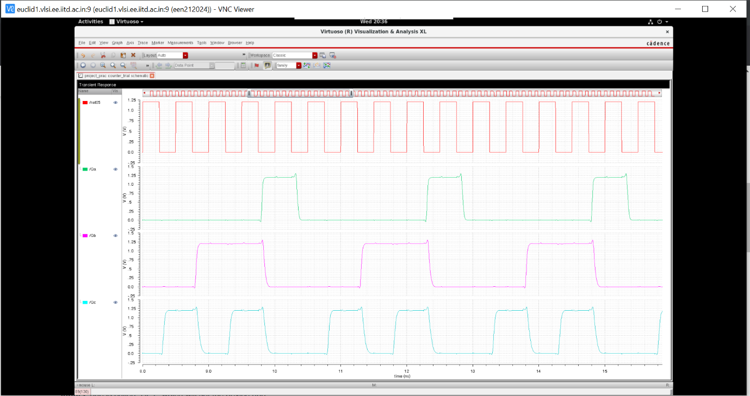

**Simulation(At 2.5GHz):**

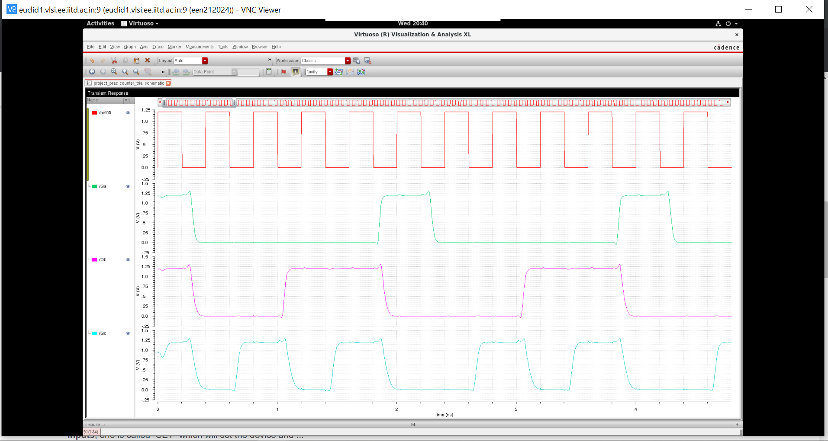

**Simulation at(3GHz):**

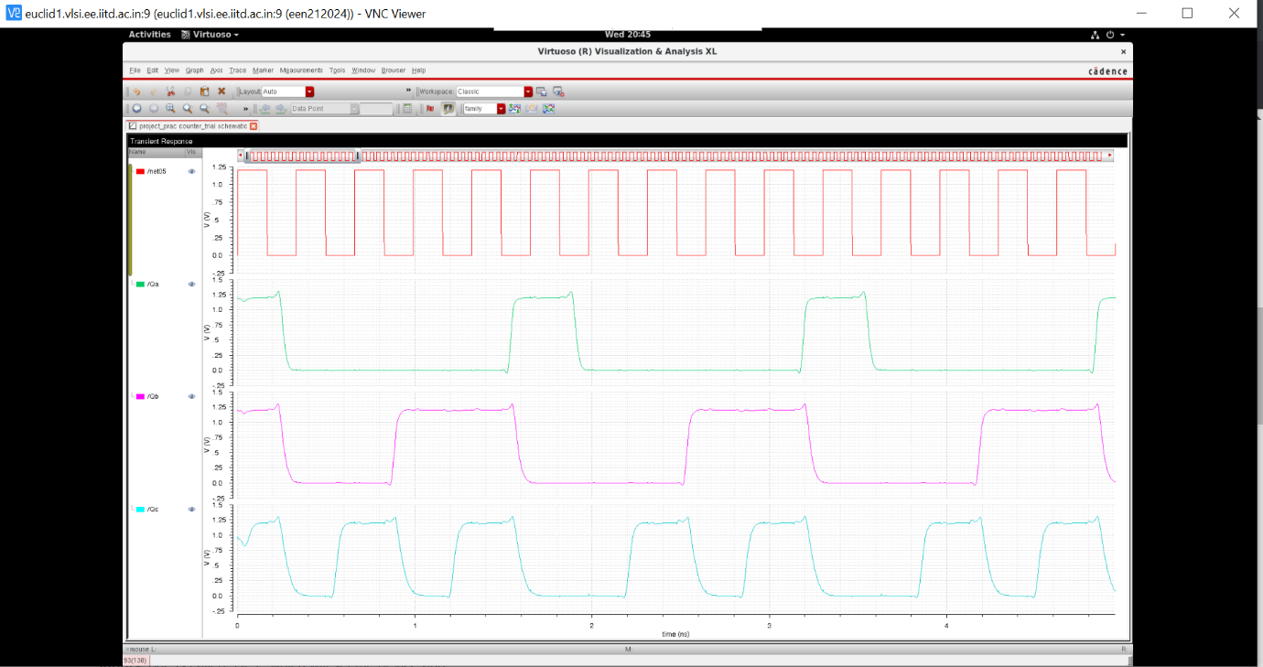

**Simulation(At 3.3GHz){Incorrect results}:**

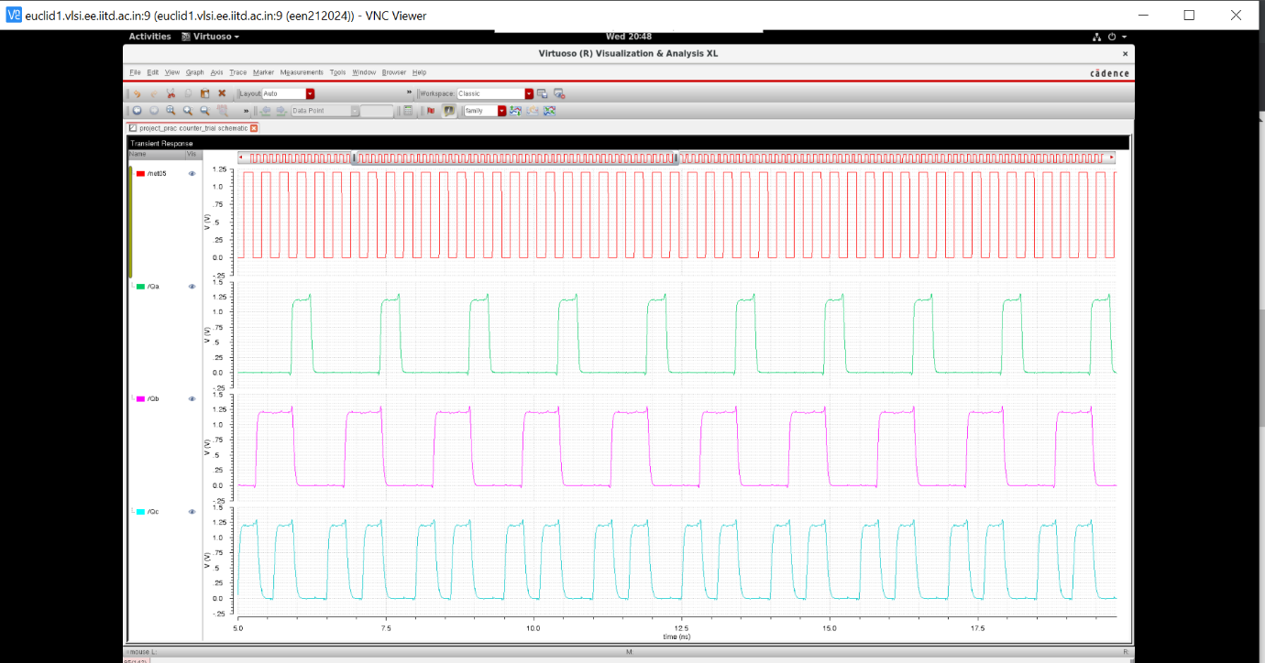

**SETUP TIME FOR THE COUNTER:**

**66.86ps**

